Writing data to S3 bucket from data bricks using pyspark
Kavana B, Software Engineer

Keywords: Databricks, AWS S3

What is Databricks?
- Databricks is an industry-leading, cloud-based data engineering tool used for processing, exploring, and transforming Big Data and using the data with machine learning models.
- It is a tool that provides a fast and simple way to set up and use a cluster to analyze and model off of Big data.
- In a nutshell, it is the platform that will allow us to use PySpark (The collaboration of Apache Spark and Python) to work with Big Data.

Why Databricks on AWS
- Simple – Databricks enables a single, unified data architecture on S3 for SQL analytics, data science and machine learning.
- Performance - Get data warehouse performance at data lake economics through SQL-optimized compute clusters.
- Proven - Thousands of customers have implemented Databricks on AWS to provide a game-changing analytics platform that addresses all analytics and AI use cases

Features of Databricks
- Compliance.
- End to end.
- Notification and logs.
- Jobs scheduler.
- Access control.
- Visualization.
- Run notebook as job.
- Integration.

Advantages of Databricks

  - Databricks compresses data from the unified Spark engine which uses higher-level libraries and supports data streaming, graph processing, SQL queries, and machine learning. It removes the complexity involved in handling such processes and making it more seamless for the productivity of developers.

Key Features of Databricks
- Language: It provides a notebook interface that supports multiple coding languages in the same environment. Using magical commands (%python, %r, %scala, and %sql), a developer can build algorithms using Python, R, Scala, or SQL. For instance, data transformation tasks can be performed using Spark SQL, model predictions made by Scala, model performance can be evaluated using Python, and data visualized using R.
- Flexibility: It is built on top of Apache Spark that is specifically optimized for Cloud environments. Databricks provides scalable Spark jobs in the data science domain. It is flexible for small-scale jobs like development or testing as well as running large-scale jobs like Big Data processing. If a cluster is idle for a specified amount of time (not-in-use), it shuts down the cluster to remain highly available.
- Data Source: It connects with many data sources to perform limitless Big Data Analytics. Databricks not only connects with Cloud storage services provided by AWS, Azure, or Google Cloud but also connects to on-premise SQL servers, CSV, and JSON. The platform also extends connectivity to MongoDB, Avro files, and many other .
Databricks Integration
- Data Sources: Databricks can read and write data from/to various data formats such as Delta Lake, CSV, JSON, XML, Parquet, and others, along with data storage providers such as Google BigQuery, Amazon S3, Snowflake, and others.
- Developer Tools: Databricks supports various tools such as IntelliJ, DataGrip, PyCharm, Visual Studio Code, and others.
- Partner Solutions: Databricks has validated integrations with third-party solutions such as Power BI, Tableau, and others to enable scenarios such as Data Preparation and Transformation, Data Ingestion, Business Intelligence (BI), and Machine Learning
Advantages of using databricks
- Databricks offers a highly secure and reliable production environment in the cloud when supported by Spark experts offering cloud managed services.
- Powerful cluster management capabilities allow you to create new clusters in seconds, dynamically scale them up and down, and share them across teams

Challenges solved by data bricks
Data spread in disparate Silos across the organization, and the use-cases to generate value from information are becoming more worldly. As the quantity and complexity of information increases, the issue only worsens as it creates the need to provide ideas more quickly. In addition, teams ‘capacity to prototype and operationalize data-driven solutions is also hampered by fragmented systems and instruments, each with restricted capacities, as well as the failure to use more data science to create smarter choices readily.
As a consequence, information experts face many severe difficulties in bridging the gap between raw data and company value-creating alternatives, including:
- Providing on-scale simple and quick access to information.
- Deploying machine learning and streaming apps of production quality.
- Using more data science to support decision-making.
Custom Spark Applications:
Databricks provides a flexible job scheduler that enables a seamless transition from prototyping to production deployment without incremental work.
- Monitor progress through custom alerts for job completion and failure, and easily view historical and in-progress results.
- Enable production deployments, especially long-running applications such as streaming, to be automatically re-launched whenever failure happens.
Writing data to S3 bucket from data bricks using pyspark

- Search for ‘Databricks’and sign up for the free trial.
- Select the cloud provider you want use—Azure, AWS, or Google Cloud—and click Get started
- Step 1: Create AWS Access Key And Secret Key For Databricks
- Step 1.1: After uploading the data to an S3 bucket, search IAM in the AWS search bar and click IAM from the search results.

- Step 1.2: Enter User name and choose Access key – Programmatic access as the AWS credential type.
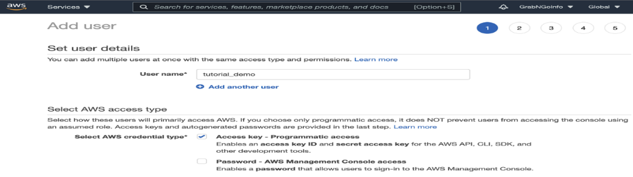
- Step 1.3: Go to the permissions section and select Attach existing policies directly. Then in the search bar type AmazonS3FullAccess and check the box in the search result.
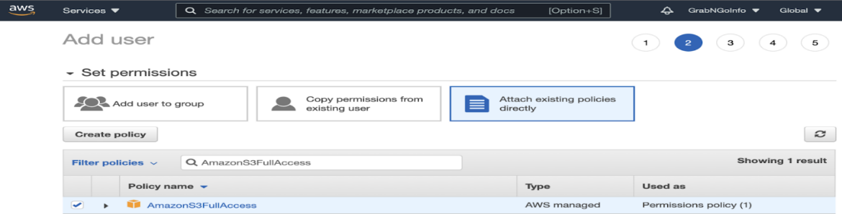

- Step 1.4: Click the blue Create user button and you will see this page. Click the Download.csv button to download the credential information.
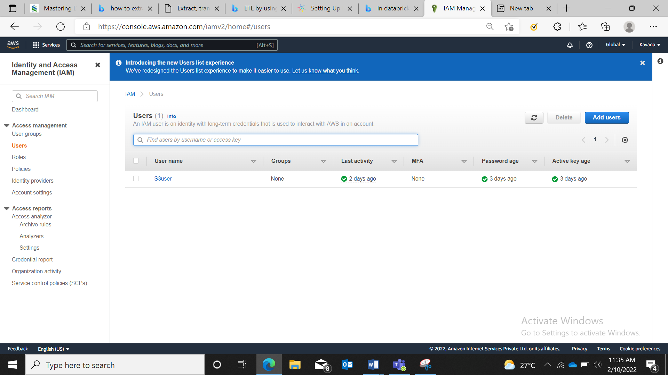
- Step 2 : Upload AWS credentials to Databricks
- Step 2.1: In the Databricks UI, click the Compute icon.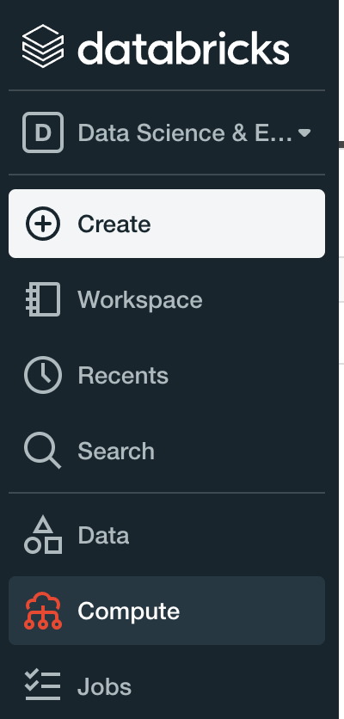

- Step 2.2: Click the blue Create Cluster icon and give the new cluster a name under Cluster Name. Choose a Databricks Runtime Version and click Create Cluster. I am using the free Databricks community edition. The paid version has more options.
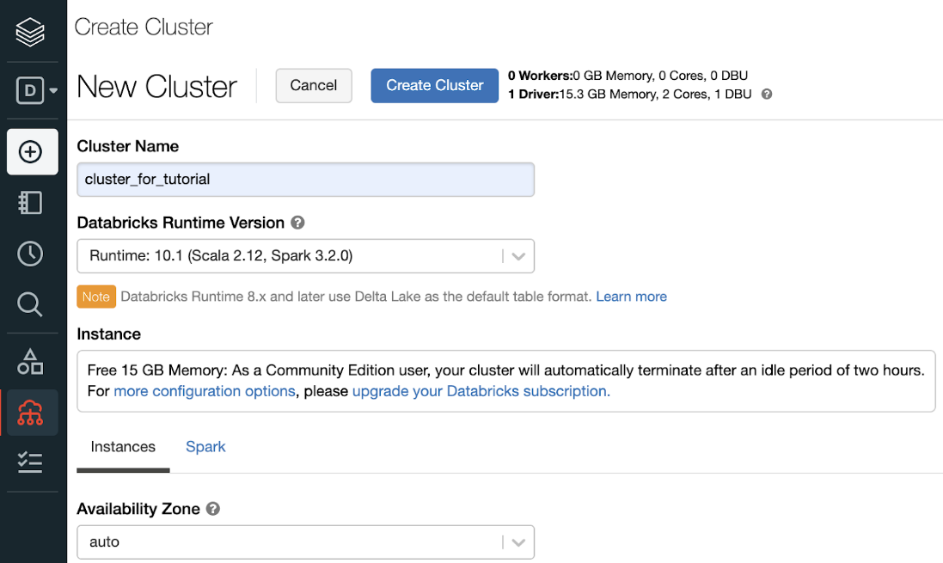
- Step 2.3: It takes a few minutes to spin up the cluster. The cluster is ready when there is a green circle in front of the cluster name.
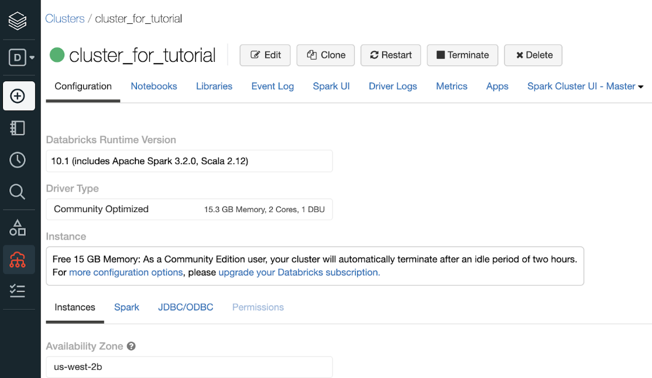

- Step 2.4: Click the Data icon and then click the Create Table button. Keep in mind that you need to have a cluster running before creating a table.
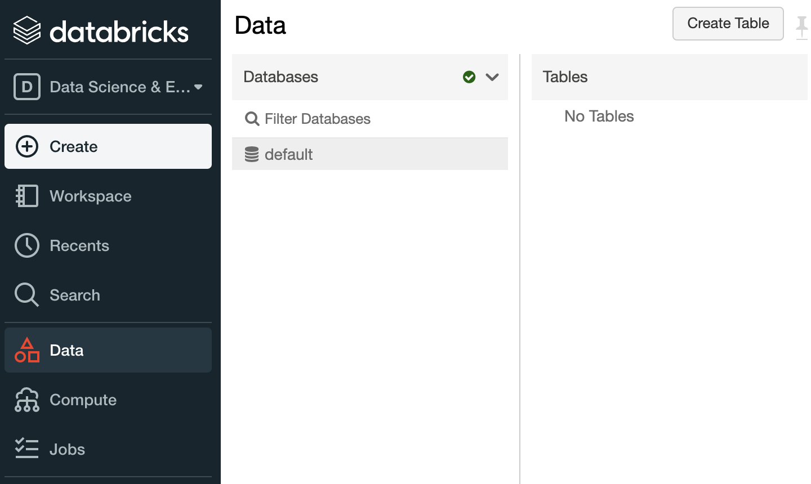
- Step 2.5: Click Drop files to upload, or click to browse and upload the csv file downloaded from AWS in step 1.
- 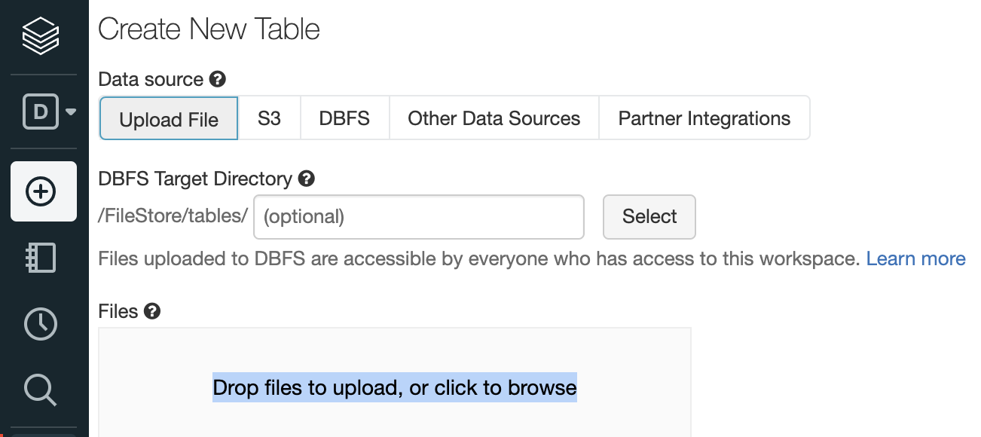

- Step 3: Mount S3 Bucket to Databricks
- Step3.1: Create a new notebook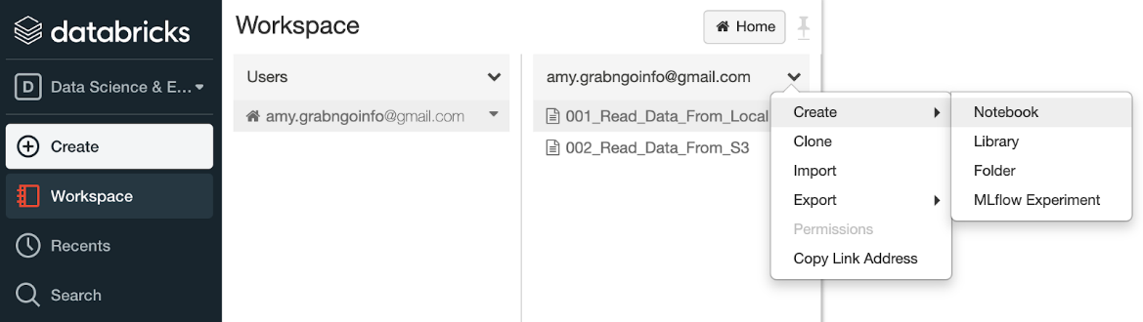
- Step 3.2: Check the contents in FileStore by running the code below in the notebook.
- dbutils.fs.ls("/FileStore/tables")
- You will see that the CSV file downloaded from AWS is in the FileStore tables folder.
- Step 3.3: Mount S3 bucket.
- We first need to import libraries. Pyspark.sql.functions has the functions for pyspark. Urllib is the package for handling urls.
from pyspark.sql.functions import *

- import urllib
- # Define file type
file_type = "csv"

- # Whether the file has a header
first_row_is_header = "true"

- # Delimiter used in the file
delimiter = ","

- # Read the CSV file to spark dataframe
aws_keys_df = spark.read.format(file_type)\
.option("header", first_row_is_header)\
.option("sep", delimiter)\.load("/FileStore/tables/aws-key.csv")
- After that, we get the access key and secret key from the spark dataframe. The secret key was encoded using urllib.parse.quote for security purposes. safe="" means every character in the secret key is encoded.
# Get the AWS access key and secret key from the spark dataframe

- ACCESS_KEY = aws_keys_df.where(col('User name')=='S3user').select('Access key ID').collect()[0]['Access key ID']
SECRET_KEY = aws_keys_df.where(col('User name')== S3user).select('Secret access key').collect()[0]['Secret access key']

- # Encode the secrete key

- ENCODED_SECRET_KEY = urllib.parse.quote(string=SECRET_KEY, safe="")
After getting the access key and secret key, it’s time to mount the S3 bucket! We can mount the bucket by passing in the S3 url and the desired mount name to dbutils.fs.mount(). It returns Ture if the bucket is mounted successfully.
- # AWS S3 bucket name
AWS_S3_BUCKET = "databrick-aws"

- # Mount name for the bucket
MOUNT_NAME = "/mnt/databrick-aws"

# Source url
- SOURCE_URL = "s3n://{0}:{1}@{2}".format(ACCESS_KEY, ENCODED_SECRET_KEY, AWS_S3_BUCKET)

- # Mount the drive
dbutils.fs.mount(SOURCE_URL, MOUNT_NAME)

About Author:


Kavana B holds Bachelor’s Degree in Telecommunication Engineering from Sri Siddhartha Institute of Technology, Tumkur. She is currently working as Software Engineer with ERS Research team and involved in Data Engineering products development.

